**Important word**

**Tableau:**

***Functionality***: Tableau is a powerful data visualization tool that allows users to create interactive and shareable dashboards and reports. It enables users to connect to various data sources, transform data into visualizations.

***Features***: Tableau offers drag-and-drop functionality for easy visualization creation, and the ability to create complex dashboards with filters.

**QlikView:**

***Functionality***: QlikView is a business intelligence tool that allowing users to explore data dynamically without predefined queries. It enables users to discover insights and relationships in their data through interactive visualizations.

***Features***: QlikView offers in-memory data processing for fast analytics, data integration from various sources, and interactive dashboards for data visualization.

**Power BI:**

***Functionality***: Power BI is a suite of business analytics tools that allows users to visualize and share insights from their data, create interactive reports and dashboards, and collaborate with others.

***Features***: Power BI offers intuitive drag-and-drop interface.

AI-powered analytics features like natural language queries.

---------------------------------------

**Data type, file type, program, language**

* **Float --------> data type**
* **String --------> data type**
* **Integer -------> data type**
* **Xml --------> file type ”extension”**
* **Jpg --------> file type ”extension”**
* **JSON --------> file type ”extension”**
* **CSV --------> file type ”extension”**
* **Xlsx --------------> file type ”extension”**
* **Opencv --------> library or program**
* **Tensorflow --------> library or program**
* **pytorch --------> library or program**
* **Powerbi --------> program**
* **Tableau --------> program**
* **PostgreSQL-----> program**
* **SSMS ----------> program**
* **SSIS ------------> program**
* **DAX--------------> language**
* **Power Query ---- > language**
* **SQL -----------> language**
* **Python --------> language**

**Charts:**

**Range plot**

It can be used to show the spread of data, trends, or patterns within a specific range.

Range plots are often used in scientific research, engineering.

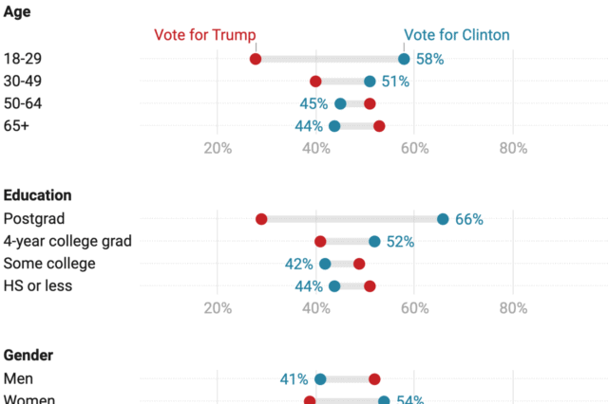

**Which chart do the following?**

1. progress toward a goal. **(Line chart)**
2. Production of multiple products in each quarter **(stacked bar chart)**
3. attributes using size and color coding **(bubble chart)**
4. the beginning and the ending headcount for your company in a year (**bar chart)**
5. Profit over Time **(Line chart)**
6. Profit relation with units produced **(scattered plot chart)**
7. Productivity of each product relation with working hours. (**stacked bar chart)**
8. Employees Age **(Histogram chart)**